John Cosentino

Nick Raynin

CSC 330

Project 2: Newspaper Delivery System

Test cases

Case 1:

This is what happens when someone logs in with the wrong username.

There should be a prompt that the login failed.

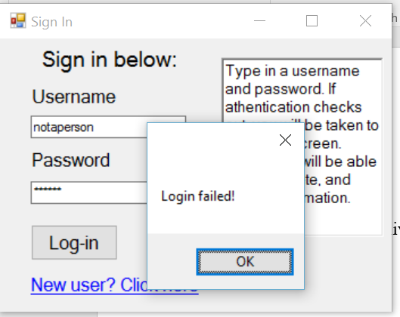

Case 2:

If you try to register a new user whose username is not already in the database, it will register that new user.

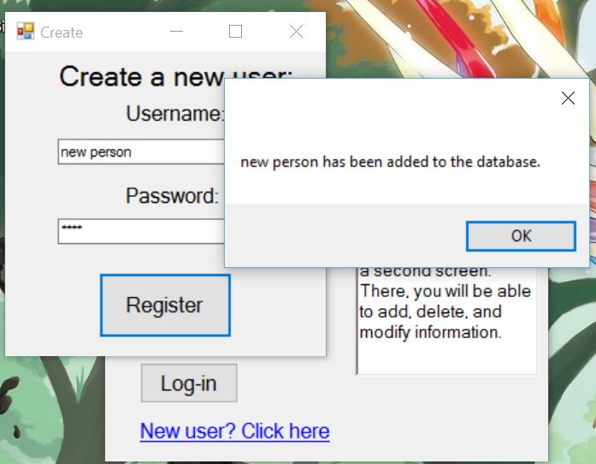

Case 3:

If the user is already in the database, then there will be a notification.

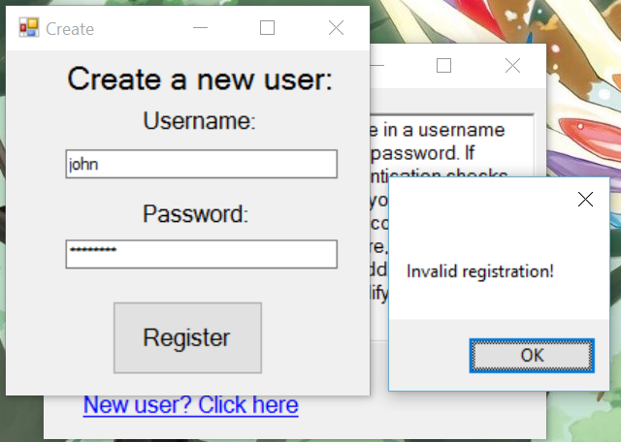

Case 4:

Upon successful login, the login screen is hidden, and a new one opens.

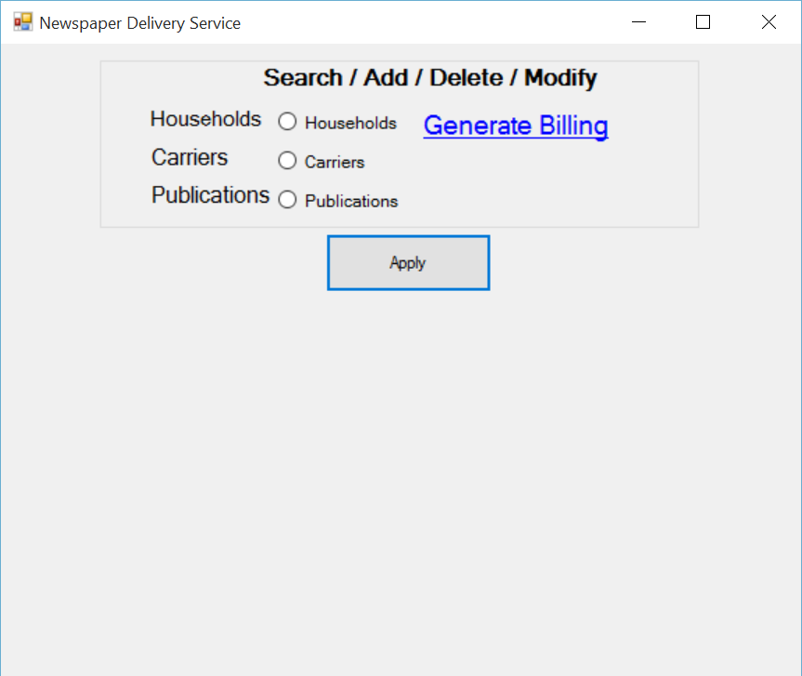

Case 5:

Upon clicking on the radio button, “Households,” the contents of the households table are shown.

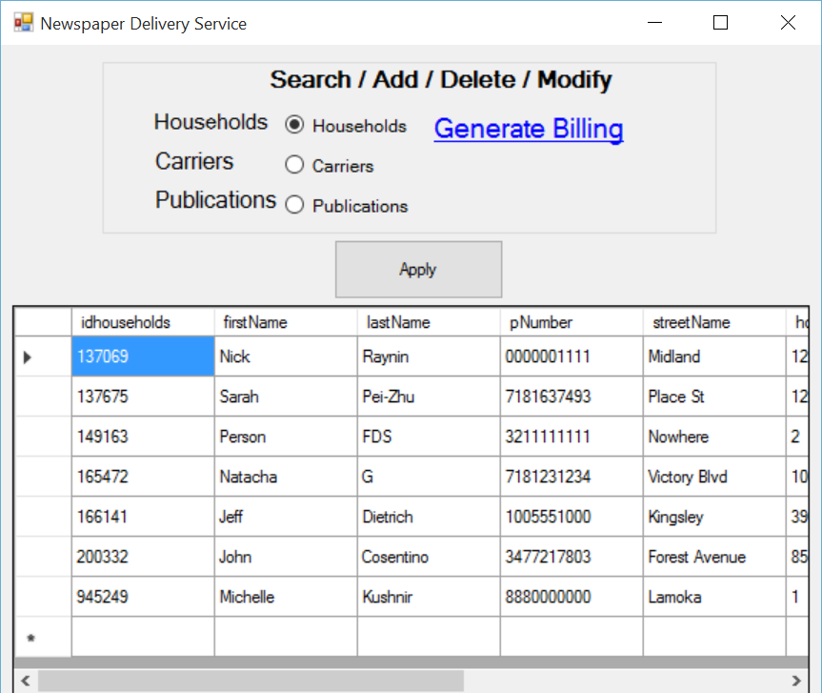

Case 6:

Upon clicking on the radio button, “Carriers,” the contents of the carriers table are shown.

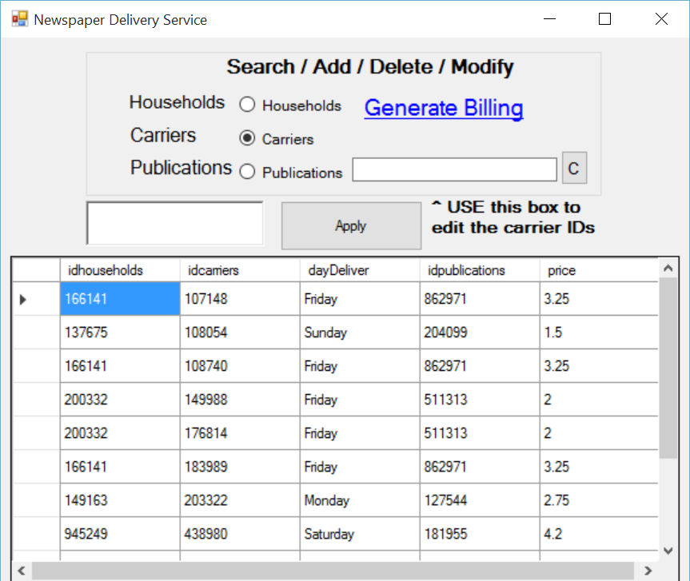

Case 7:

Upon clicking on the radio button, “Publication,” the contents of the publications table are shown.

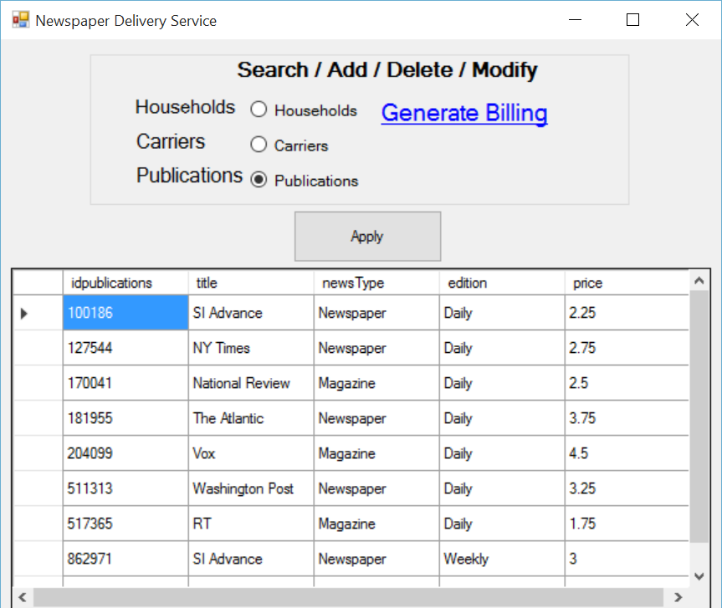

Case 8:

Hitting the Generate Billing link opens up a new window

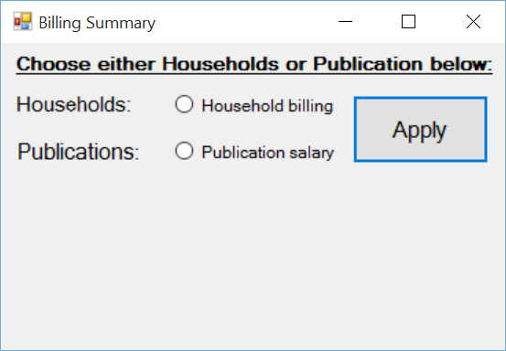

Case 9:

Clicking “Apply” shows the amount due from a household, and how many subscriptions are assigned to that household

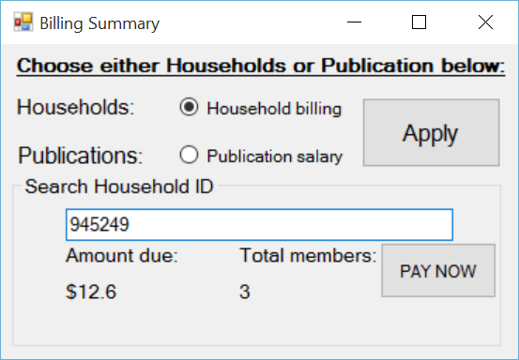

Case 10:

Clicking “Apply” shows the amount due to a publication, and how many subscriptions are assigned to that publication

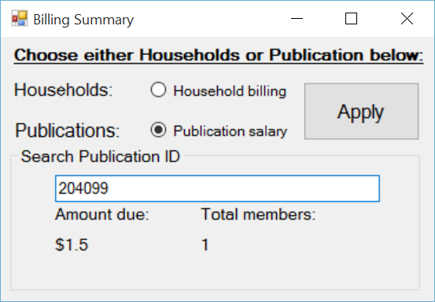

Case 11:

If “PAY NOW” is clicked, then the amount due becomes 0, followed by the appropriate pop-up.

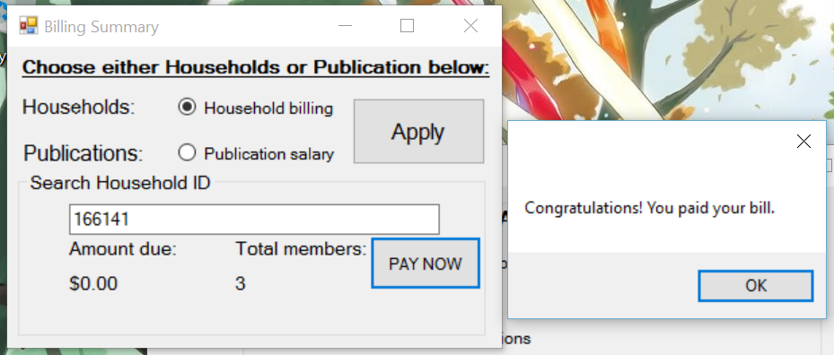

Case 12:

Since IDs are numeric, searching for an ID with alphabetical digits will create an exception.

